Data Backup Procedure

Developed By

Shrinivas Vanungare

(Shrinivas@cmu.edu)

Table of Content
1. Introduction 3
1.1 Purpose 3
2. Procedure 3
2.1 Opening MS SQL Server 3
2.2 Opening Data back up tool 4

Introduction
Purpose | This document gives detail procedure to how to backup data from MS SQL server.

Procedure
Opening MS SQL Server | - Open MS SQL sever as shown in picture
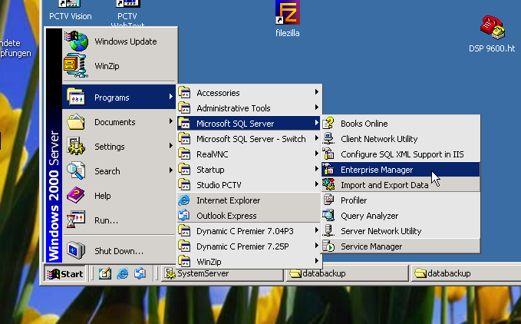
Opening Data back up tool | - Right click on MACROMIZER database node  - Then select All Tasks and Backup Database as shown in picture  - You will see new pop window
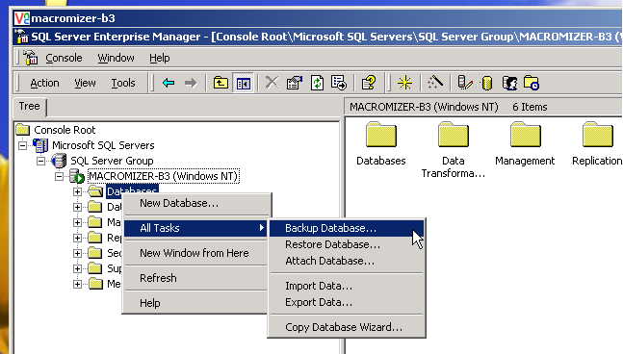
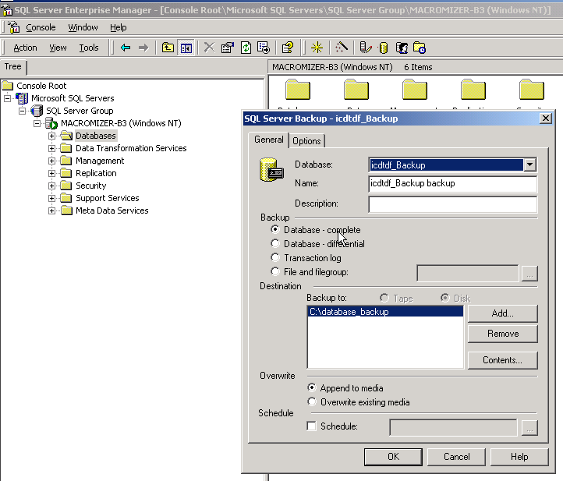
- Then select or add new data back up destination and then click ‘Ok ‘ button as shown in picture
- Then tool will starts for backup
- You will get back-up in your specified location

